Introduction:

California saw the deadliest and most destructive wildfire season in 2018. The series of wildfires left the largest historical record of burned acreage, estimated to have caused a whopping $3.5 billion in damages. In late 2018, many Californians in populous cities like Los Angeles had to evacuate to avoid the expanding blazes and pollution. Understanding changes in traffic congestion and mean travel times in this period can provide valuable insights into how evacuation scenarios play out and how they might be made more efficient. Luckily, this insight can be gained by analyzing Uber’s Movement dataset which provides data on average travel times between set boundaries. For instance, the datset allows us to observe the average travel time increases across time between different zones and the duration of these elevated periods.

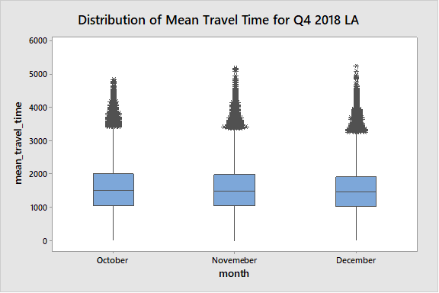

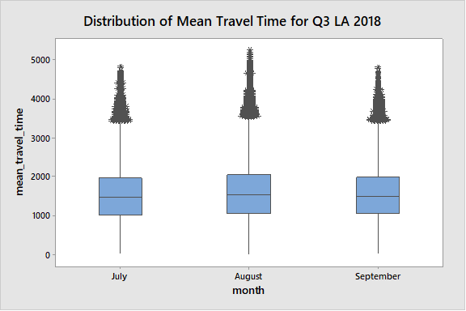

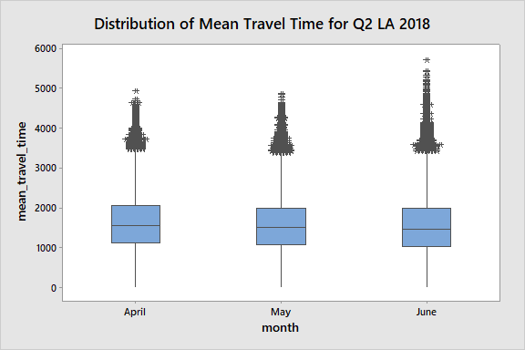

**Descriptive Statistics: mean_travel_time**

**Statistics Q4**

|  |  |  |  |  |  |  |  |  |  |  |
| --- | --- | --- | --- | --- | --- | --- | --- | --- | --- | --- |
| **Variable** | **month** | **N** | **N\*** | **Mean** | **SE Mean** | **StDev** | **Minimum** | **Q1** | **Median** | **Q3** |
| **mean_travel_time** | **10** | **1687096** | **0** | **1538.5** | **0.522** | **678.0** | **2.83** | **1044.6** | **1497.3** | **1995.2** |
|  | **11** | **1760989** | **0** | **1527.2** | **0.502** | **665.7** | **3.06** | **1045.3** | **1492.1** | **1971.8** |
|  | **12** | **1764530** | **0** | **1489.7** | **0.483** | **641.2** | **2.99** | **1027.8** | **1460.3** | **1919.3** |

|  |  |  |
| --- | --- | --- |
| **Variable** | **month** | **Maximum** |
| **mean_travel_time** | **10** | **4835.5** |
|  | **11** | **5172.3** |
|  | **12** | **5244.3** |

**Statistics Q3**

|  |  |  |  |  |  |  |  |  |  |  |
| --- | --- | --- | --- | --- | --- | --- | --- | --- | --- | --- |
| **Variable** | **month** | **N** | **N\*** | **Mean** | **SE Mean** | **StDev** | **Minimum** | **Q1** | **Median** | **Q3** |
| **mean_travel_time** | **7** | **1742121** | **0** | **1511.6** | **0.514** | **678.1** | **4.62** | **1014.9** | **1459.8** | **1967.5** |
|  | **8** | **1773424** | **0** | **1564.4** | **0.525** | **698.7** | **4.96** | **1053.0** | **1514.7** | **2034.8** |
|  | **9** | **1774604** | **0** | **1531.8** | **0.503** | **670.1** | **3.82** | **1044.8** | **1490.4** | **1982.8** |

|  |  |  |
| --- | --- | --- |
| **Variable** | **month** | **Maximum** |
| **mean_travel_time** | **7** | **4824.0** |
|  | **8** | **5236.2** |
|  | **9** | **4806.9** |

**Statistics Q2**

|  |  |  |  |  |  |  |  |  |  |  |
| --- | --- | --- | --- | --- | --- | --- | --- | --- | --- | --- |
| **Variable** | **month** | **N** | **N\*** | **Mean** | **SE Mean** | **StDev** | **Minimum** | **Q1** | **Median** | **Q3** |
| **mean_travel_time** | **4** | **1795165** | **0** | **1589.5** | **0.506** | **678.6** | **4.17** | **1103.4** | **1558.6** | **2045.9** |
|  | **5** | **1753158** | **0** | **1536.8** | **0.499** | **661.3** | **2.91** | **1061.8** | **1502.2** | **1980.7** |
|  | **6** | **1710290** | **0** | **1524.6** | **0.527** | **689.7** | **3.27** | **1021.4** | **1465.7** | **1981.5** |

|  |  |  |
| --- | --- | --- |
| **Variable** | **month** | **Maximum** |
| **mean_travel_time** | **4** | **4920.8** |
|  | **5** | **4857.2** |
|  | **6** | **5694.3** |